Experiment 15
Program:
import cv2
import numpy as np
# Read the image
img = cv2.imread("image.jpg")
# Convert image to grayscale
gray = cv2.cvtColor(img, cv2.COLOR_BGR2GRAY)
# Convert to float32
gray = np.float32(gray)
# Apply Harris Corner Detection
corners = cv2.cornerHarris(gray, 2, 3, 0.04)
# Dilate the corner points to enhance them
corners = cv2.dilate(corners, None)
# Mark corners in the original image
img[corners > 0.01 * corners.max()] = [0, 0, 255]
# Display the image
cv2.imshow("Harris Corners", img)
cv2.waitKey(0)
cv2.destroyAllWindows()
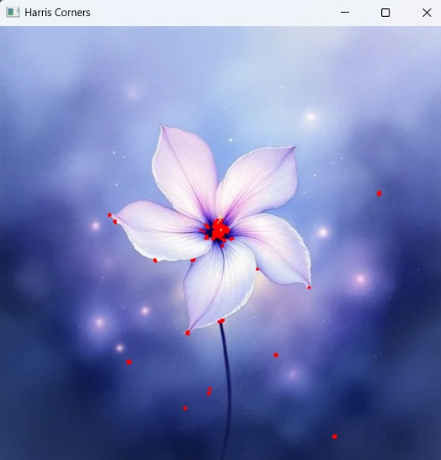
Output:

